

Semester 1 Examination 2010

Question/Answer Booklet

MATHEMATICS 3C/3D

Section Two

(Calculator Assumed) Student Number

Name
Teacher ___________________________________

Time allowed for this section

Reading time before commencing work: 10 minutes
Working time for paper: 100 minutes

Material required/recommended for this section

To be provided by the supervisor
Question/answer booklet for Section Two.
Formula sheet.

To be provided by the candidate
Standard items: pens, pencils, pencil sharpener, highlighter, eraser, ruler.
Special items: drawing instruments, templates, notes on up to two unfolded sheets of A4 paper, and up to three calculators, CAS, graphic or scientific, which satisfy the conditions set by the Curriculum Council for this course.

Important note to candidates
No other items may be taken into the examination room. It is your responsibility to ensure that you do not have any unauthorised notes or other items of a non-personal nature in the examination room. If you have any unauthorised material with you, hand it to the supervisor before reading any further.

Structure of this examination

 | Number of questions | Working time (minutes) | Marks available
Section One  Calculator Free | 6 | 50 | 40
This Section (Section 2)  Calculator Assumed | 12 | 100 | 80
Total marks |  |  | 120

Instructions to candidates

- The rules for the conduct of WACE external examinations are detailed in the booklet WACE Examinations Handbook. Sitting this examination implies that you agree to abide by these rules.

- Answer the questions in the spaces provided.

- Spare answer pages are provided at the end of this booklet. If you need to use them, indicate in the original answer space where the answer is continued i.e. give the page number.

- Show all working clearly. Any question, or part question, worth more than 2 marks requires valid working or justification to receive full marks. If you repeat an answer to any question, ensure that you cancel the answer you do not wish to have marked.

Section Two: Calculator-assumed (80 Marks)
This section has twelve (12) questions. Answer all questions. Write your answers in the space provided.
Spare pages are included at the end of this booklet. They can be used for planning your responses and/or as additional space if required to continue an answer.
  - Planning: If you use the spare pages for planning, indicate this clearly at the top of the page.
  - Continuing an answer: If you need to use the space to continue an answer, indicate in the original answer space where the answer is continued, i.e. give the page number. Fill in the number of the question(s) that you are continuing to answer at the top of the page.

Suggested working time for this section is 100 minutes.

Question 7 (8 marks)
A basketball training squad consists of 4 guards, 2 centres and 3 forwards. A team of 5 is to be chosen to start the game.
In how many ways can this starting team be chosen if:
(a) there are no restrictions? (1 mark)

(b) the team must consist of 2 guards, 1 centre and 2 forwards? (2 marks)

(c) the team includes at most 2 centres? (3 marks)

Julie is a centre player and is chosen in the team. If the other players are selected at random, what is the probability that:
(d) Julie is the only centre in the team? (2 marks)
Question 8 (5 marks)
(a) State the natural domain and corresponding range for gof(x) given that (2 marks)
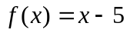 and 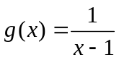

(b) If f(x) = 3x² − 2 and h(x) = 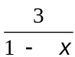 find h(f(x). (1 mark)

(c) A composite function is defined by the equation h(f(x)) = 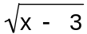 − 4. Determine the domain and range of this function for x real. (2 marks)

Question 9 (5 marks)
In the first five seconds of inflation, the relationship between the radius (r cm) and time (t sec) of a spherical party balloon are related by the formula
r = −t(t − 10)
(a) Show that the relationship between volume (V cm³) and time is given by V = 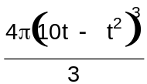
(1 mark)

(b) Determine the exact volume of the balloon 3 seconds after first being inflated. (1 mark)

(c) Determine the approximate change in volume as t increases from 3 to 3.01 sec. (3 marks)

Question 10 (5 marks)

Consider the function f(x) = x³ + ax² + 2x + b where a and b are constants

(a) Find an expression for the gradient of the curve (1 mark)

(b) Given that the tangents at A(0, b) and B(2, 5) are parallel, find the value of a and b.
(4 marks)

Question 11 (5 marks)
A mathematics teacher, in conversation with a colleague explained that her Year 10 class of students could be classified as
Well behaved (Group A consisting of 15 students)
Moderately behaved (Group B consisting of 10 students)
Poorly behaved (Group C consisting of 5 students)
She also mentioned that when there is a full moon on any particular lunar cycle the probability that a student will misbehave one or more times is 0.05, 0.15 and 0.3 for a randomly selected student from Group A, B and C respectively.
(a) What is the probability that a randomly selected student will misbehave at least once within a lunar cycle?
(2 marks)

(b) If a randomly selected student had misbehaved at least once during a lunar cycle, what is the probability the student was from Group C? (3 marks)

Question 12 (8 marks)
- Sand is falling onto the top of a pile at the rate of 2 cubic centimetres per hour. The pile maintains a conical shape in which the radius of the base is always one half of the height.
How fast is the height of the pile growing when it is 5 metres high? (4 marks)

- Given that 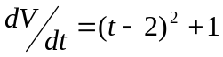, find
- The instantaneous rate of change of V with respect to t when t=4 (1 mark)

- The net change in V when t changes from t=1 to t=4 (2 marks)

- The average rate of change of V in the interval 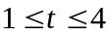seconds (1 mark)

Question 13 (8 marks)
On the axes below draw the curves 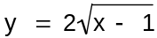 and y = x³ − x² − 5x − 4.
 (3 marks)
(a) Determine any points of inflection. (1 mark)

(b) Explain why there will only be one turning point. (1 mark)

(c) Use calculus techniques to determine where the exact turning points occur. (3 marks)

Question 14 (8 marks)
A function is defined as y = pxe^{qx} where p and q are constants.
(a) Determine 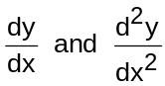. (3 marks)

(b) Using the results found in (a), determine the values for p and q so that y has a maximum of 1 when x = (5 marks)

Question 15 (8 marks)
a) A “paraboloid” is formed by revolving a parabola,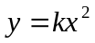, about its axis of symmetry. The paraboloid is bounded by a plane cutting the axis of symmetry perpendicularly at the point (0,12). The intersection of this plane and the paraboloid is a circle of radius 3 units. Determine the volume of the paraboloid. (5 marks)

(b) The population of a particular country (P million people) was changing such that t years after records were first kept
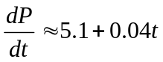
If it is now 20 years since records were first kept use the above rule to determine an approximate value, to the nearest half million, for the increase in population in the next eight years. (3 marks)
Question 16 (8 marks)
A closed cylindrical can is to be made to hold 1 litre of oil.
Find the dimensions that will minimise the cost of the metal to make the can. Assume the metal joins perfectly and no overlaps are required .

Question 17 (6 marks)
Two competing cyclist are riding with constant speed. At 12 midday cyclist X is 40 metres north of a judge and is riding east at 9m/s, while cyclist Y is 70 metres east of the judge and is riding north at 7m/s.
(a) Show diagrammatically this situation (a scale diagram is not required) (1 mark)

(b) If the distance between the cyclist t seconds later is D metres, show that
D² = 6500 −1820t + 130t² (3 marks)

(c) Determine the time the cyclists are closest together and determine the minimum distance between them. (2 marks)

Question 18 (5 marks)
The cross section of land can be modeled by the equation

H = 0.00003d(d − 30)(d − 50)(100 − d) where H and d are, respectively, the height (in metres) above a fixed horizontal level and the distance (in metres) from a fixed point.

The cross section has been shown in the diagram below.

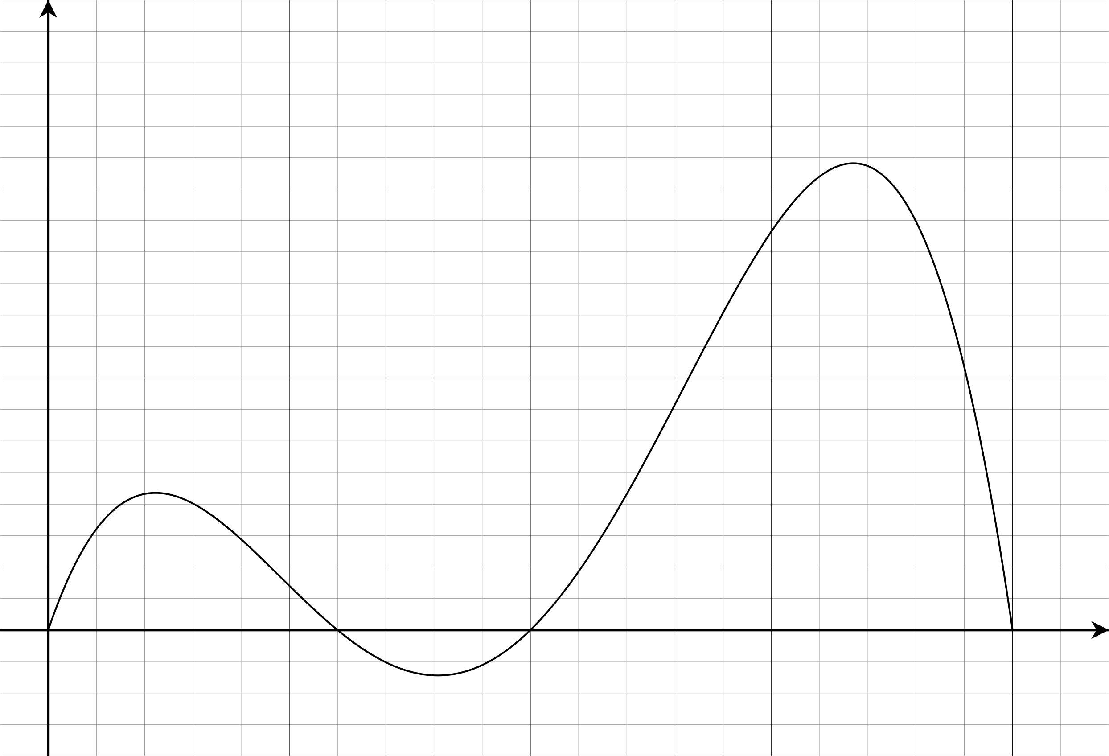

A tunnel, 10m high, will be constructed through the two hills. Show how the cross sectional area of soil removed can be determined using integrals and mensuration (measurement) formula. There is
no need to evaluate your answer. (5 marks)
Additional working space
Additional working

